**Data Getta User Manual**

**AI for Auburn University Baseball - Database**

**User Documentation**

Authors:

Teddy Cooke

Laura Cromwell

Frankie Donze

Caden Garrett

Micah Key

Braden Mosley

Jacob Munroe

Annie Murphy

COMP 4710: Senior Design Team #9 Orange and Blue

Department of Computer Science and Software Engineering

Samuel Ginn College of Engineering, Auburn University

**Table of Contents**

**System Metaphor 3**

**System Summary 3**

**How to: Log In 4**

**How to: View Auburn’s Page 5**

View Auburn from Left Bar Navigation 5

View Auburn from Conferences 5

View Roster 6

View Pitching Stats 7

View Batting Stats 8

**How to: View Another Team’s Page 9**

Finding a Specific Team 9

View Roster (Example: Clemson) 10

View Pitching Stats (Example: Clemson) 11

View Batting Stats (Example: Clemson) 12

**How to: View a Player’s Page 13**

View a Pitcher’s Page 13

View a Pitcher’s Statistics 14

View a Pitcher’s AI Models 15

View a Batter’s Page 16

View a Batter’s Statistics 17

**Connect to Auburn’s VPN 18**

## **System Metaphor**

The baseball database system can be compared to that of a scoreboard. Similar to how a scoreboard at a baseball stadium keeps track of every play and outcome during a game, our database and UI serve as the ultimate source of information for coaches and players. It records every aspect of the game, from player statistics and team performance to the differing scores between the two teams playing. Just as fans rely on the scoreboard to stay updated on the game’s progress, coaches and players can rely on our database to access all relevant information. It provides a comprehensive view of the baseball game, comparing pitchers versus opposing batters, allowing coaches and players to make data-driven decisions and improve overall game performance.

## **System Summary**

The Data Getta website hosts all the Trackman data collected from every D1 college baseball game and stores that data for Auburn Baseball to view and analyze. A user can visit the roster, pitching stats, and batting stats for Auburn and other teams. A user can also navigate to a specific player’s page to view their statistics, as well as the AI models developed by other senior design teams.

## 

## **How to: Log In**

1. Two options
   1. Make sure you are connected to AU_WiFi with your Auburn credentials
   2. Connect to Auburn VPN with your Auburn credentials (see instructions)
2. Navigate on your web browser to datagetta.app
   1. This will take you to http://datagetta.cse.eng.auburn.edu/

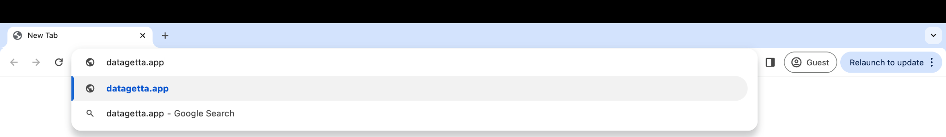

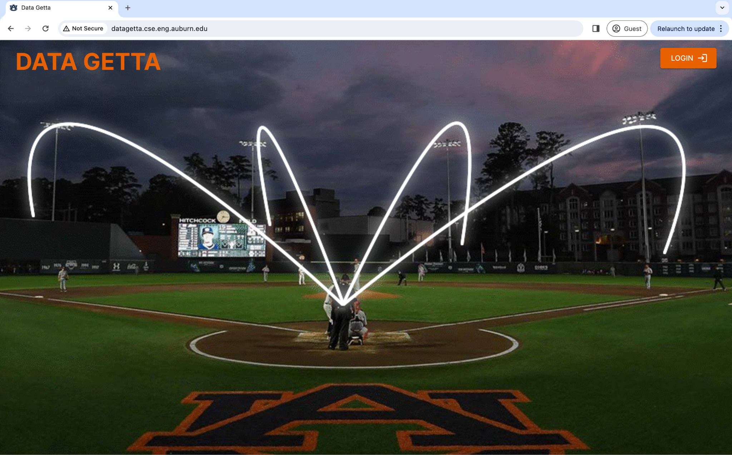

1. Click the “Login” button at the top right corner of the page
2. After logging in you will be directed to the home page

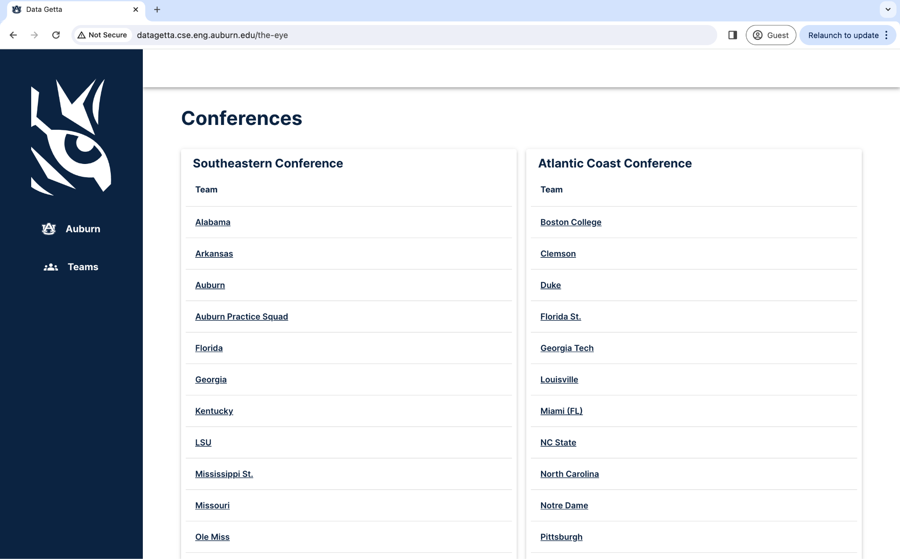

## **How to: View Auburn’s Page**

There are two ways you can navigate to Auburn’s Team Page: from left bar navigation, and from the “Conferences” page.

### **View Auburn from Left Bar Navigation**

1. On the blue bar on the left side of the screen, click “Auburn”

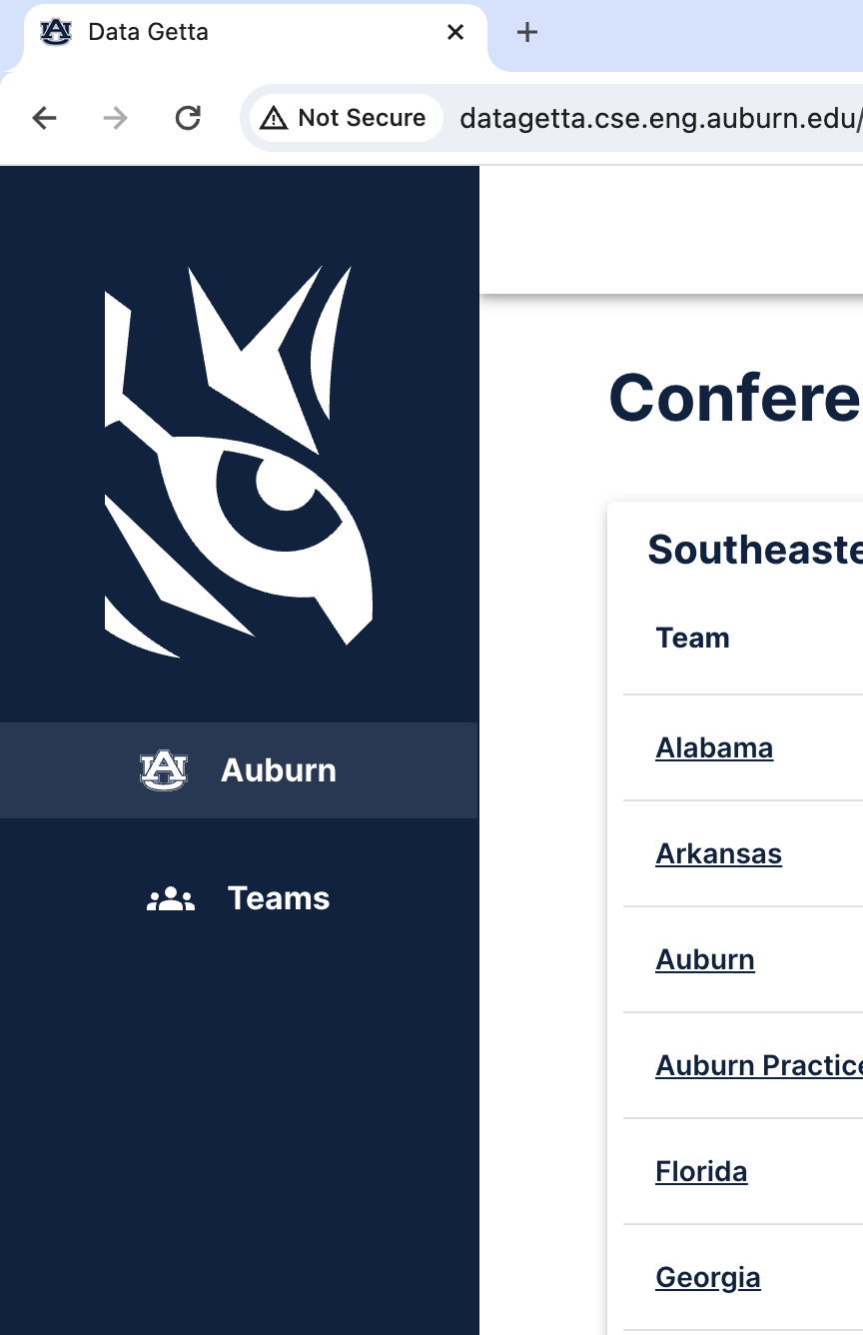

### **View Auburn from Conferences**

1. Navigate on the “Conferences” page to “Southeastern Conference”. “Southeastern Conference” should be the first conference listed on the page

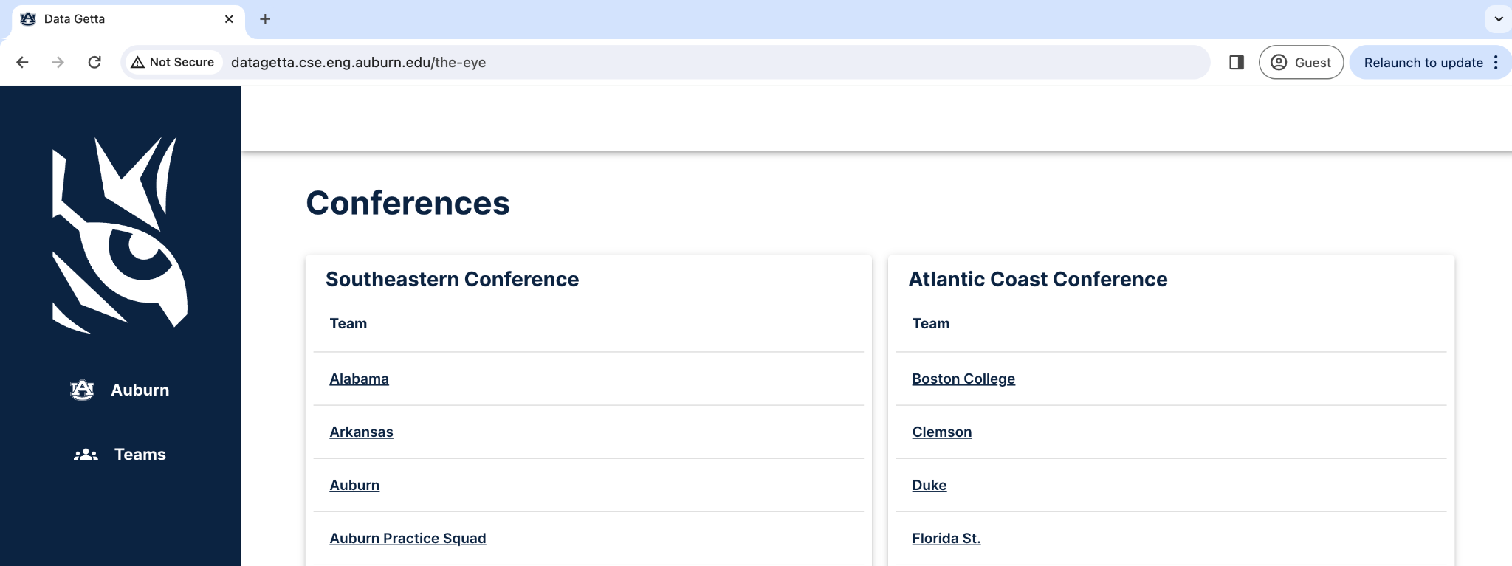

1. Click on “Auburn” which should be the third option under “Southeastern Conference”

### 

### **View Roster**

By navigating to the “Auburn” page, you are automatically taken to the roster

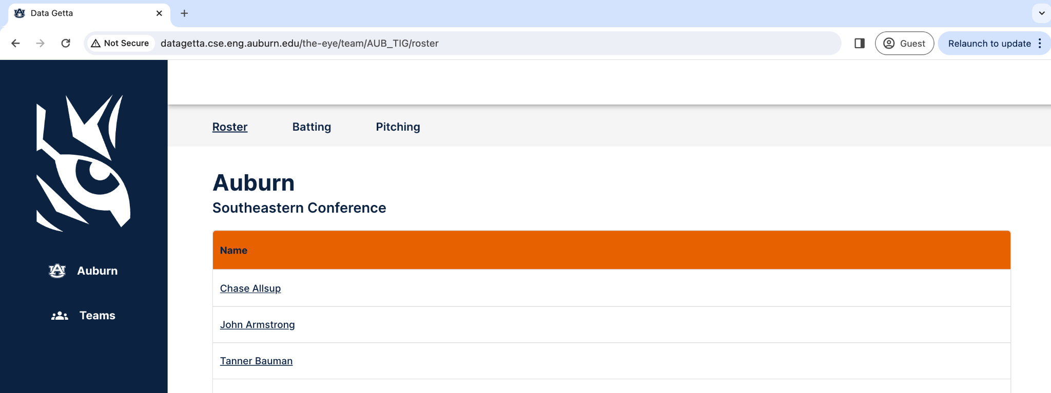

If you are on another page, you can navigate back to the Roster page by clicking on “Roster” on the top bar

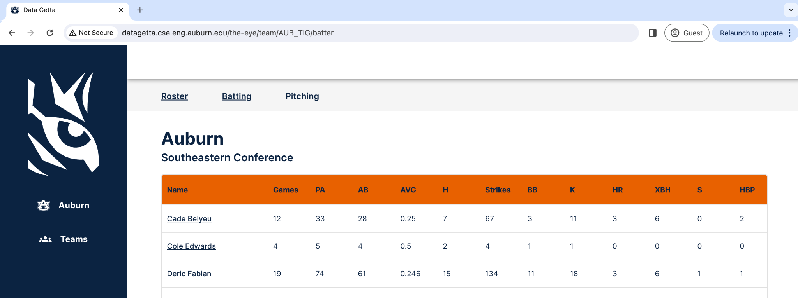

### 

### **View Pitching Stats**

You can navigate to Auburn’s Pitching Page by clicking on “Pitching” on the top bar

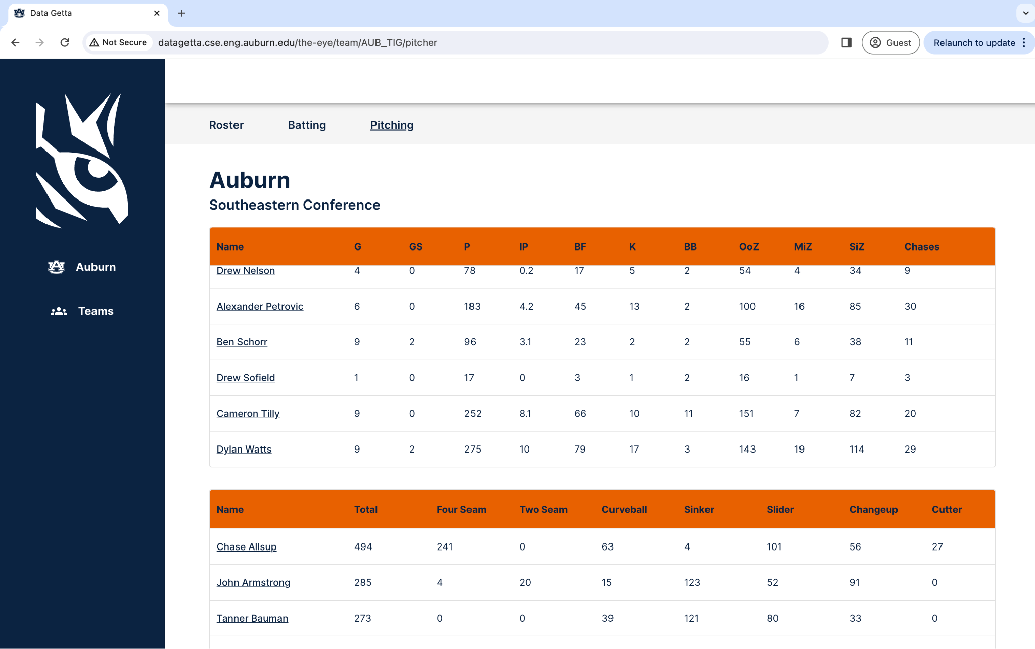

The tables describe statistics such as Games Played, Games Started, Innings Pitched, etc. for each player that pitches. More players can be viewed by hovering over the table and scrolling down. More statistics may be available for view by scrolling left or right on the table itself.

You can also click on a specific player’s name to see a more detailed view of their statistics. For more information, visit the View a Pitcher’s page section of the manual.

### 

### **View Batting Stats**

You can navigate to Auburn’s Batting Page by clicking on “Batting” on the top bar

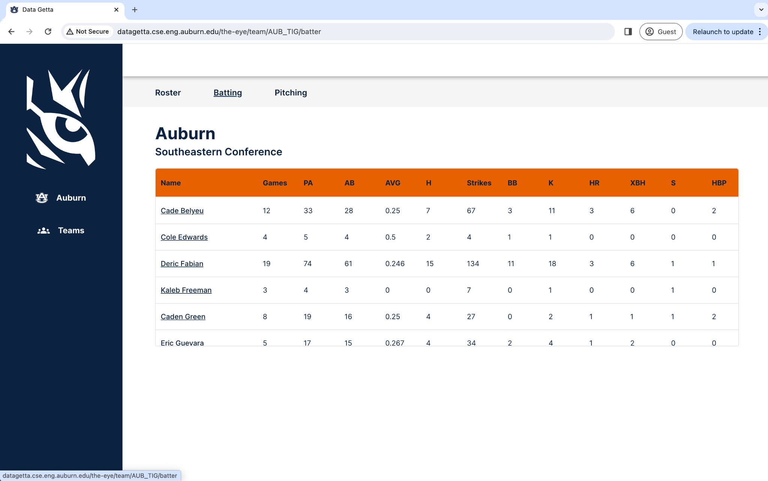

The tables describe statistics such as Games Played, Plate Appearances, At Bats, etc. for each player that pitches. More players can be viewed by hovering over the table and scrolling down. More statistics may be available for view by scrolling left or right on the table itself.

You can also click on a specific player’s name to see a more detailed view of their statistics. For more information, visit the View a Batter’s Page section of the manual.

## 

## **How to: View Another Team’s Page**

### **Finding a Specific Team**

Upon logging into the website you are automatically taken to the “Conferences” Page. From there you can scroll to view all possible conferences, and you can click a specific team in that conference



To navigate back to the “Conferences” Page from another page in the website, navigate to the blue bar on the left side of the page and click on “Teams”



### 

### 

### **View Roster (Example: Clemson)**

By navigating to the Clemson page, you are automatically taken to the roster

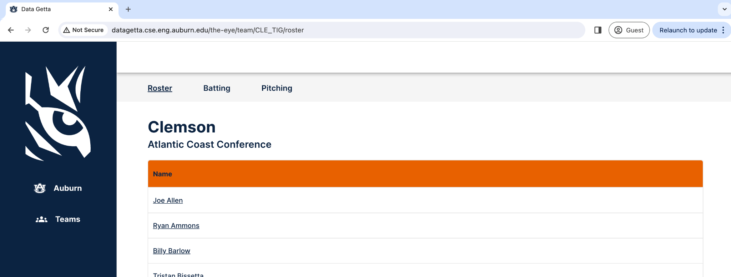

If you are on another page, you can navigate back to the Roster page by clicking on “Roster” on the top bar

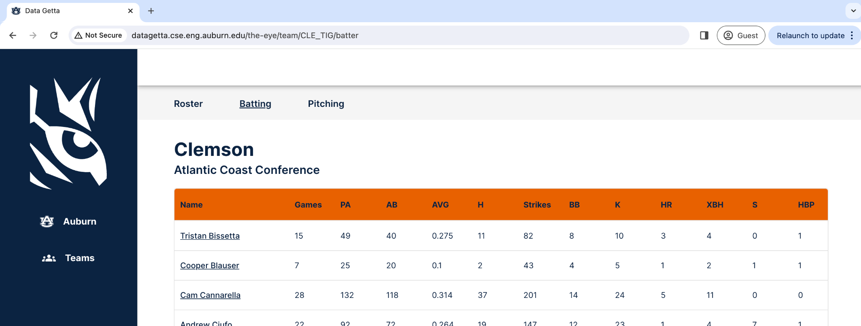

### 

### **View Pitching Stats (Example: Clemson)**

You can navigate to Clemson’s Pitching Page by clicking on “Pitching” on the top bar

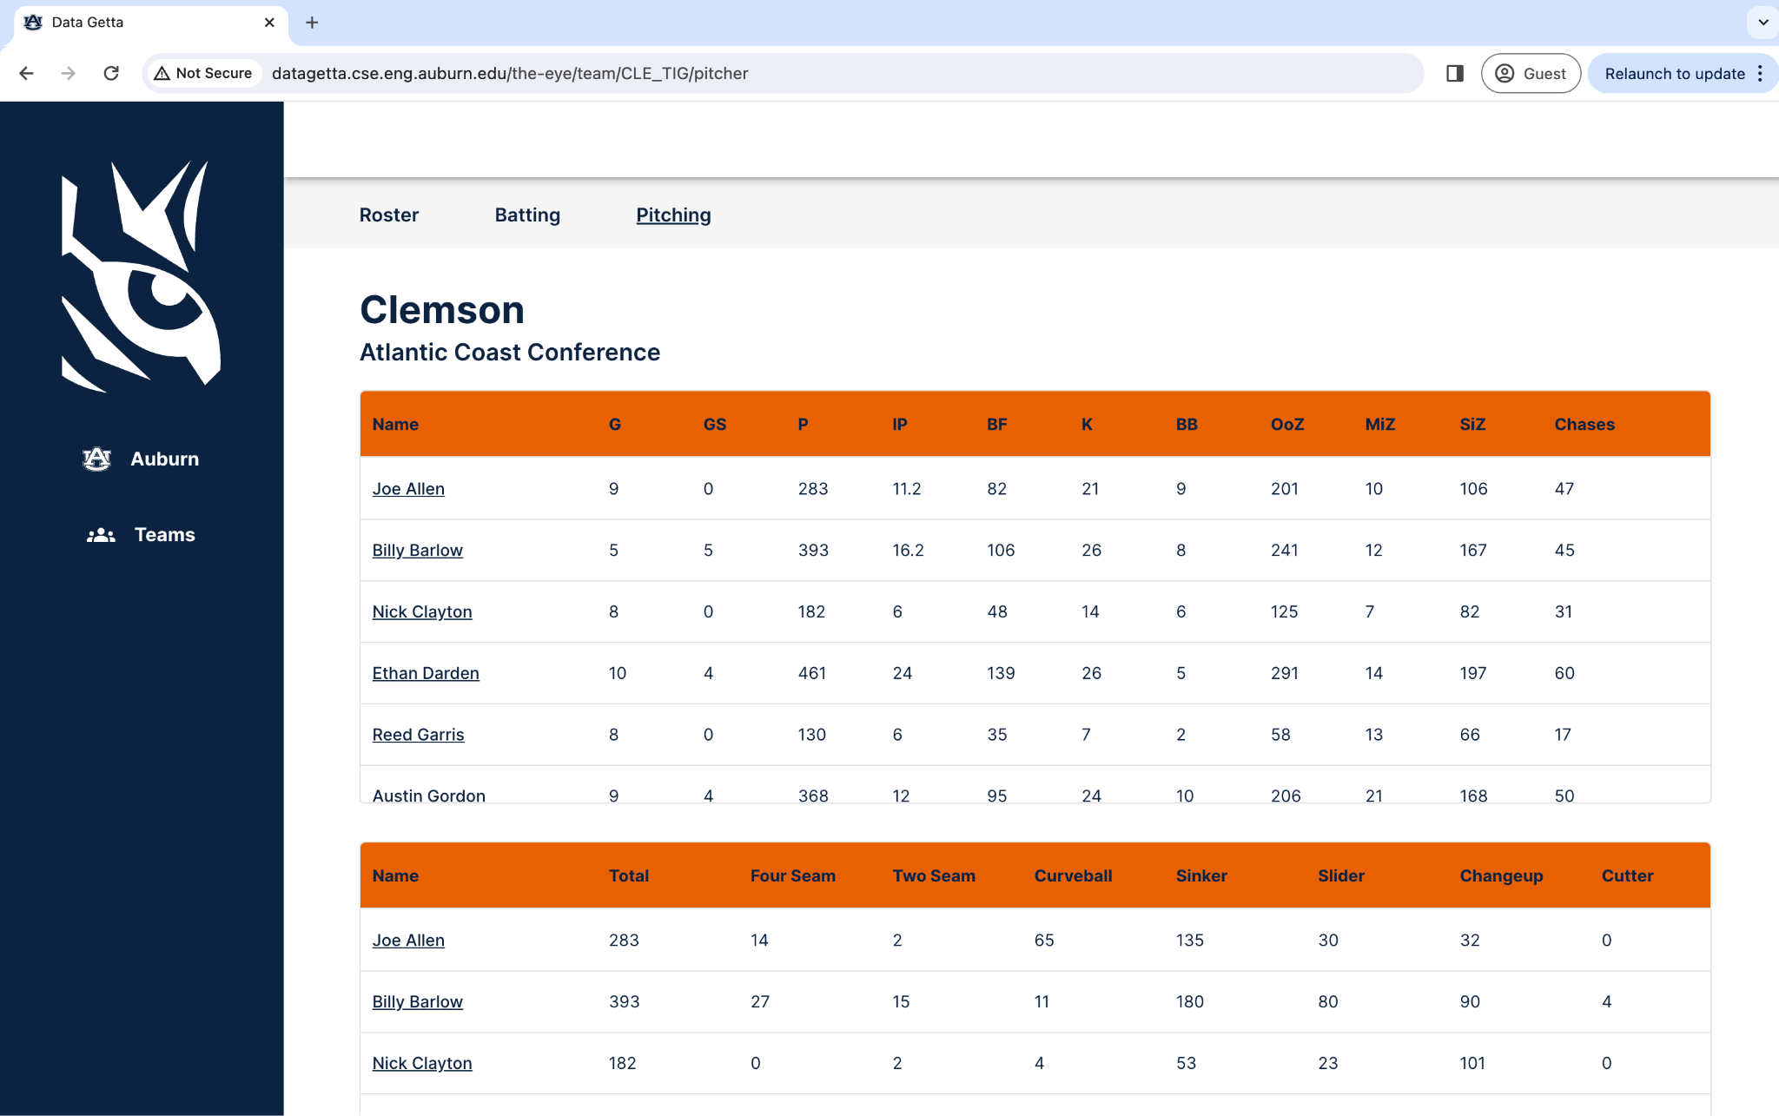

The tables describe statistics such as Games Played, Games Started, Innings Pitched, etc. for each player that pitches. More players can be viewed by hovering over the table and scrolling down. More statistics may be available for view by scrolling left or right on the table itself.

You can also click on a specific player’s name to see a more detailed view of their statistics. For more information, visit the View a Pitcher’s page section of the manual.

### 

### **View Batting Stats (Example: Clemson)**

You can navigate to Clemson’s Batting Page by clicking on “Batting” on the top bar



The tables describe statistics such as Games Played, Plate Appearances, At Bats, etc. for each player that pitches. More players can be viewed by hovering over the table and scrolling down. More statistics may be available for view by scrolling left or right on the table itself.

You can also click on a specific player’s name to see a more detailed view of their statistics. For more information, visit the View a Batter’s Page section of the manual.

## 

## **How to: View a Player’s Page**

You can view any player’s page by navigating to a team’s “Roster” page, scroll to the player you want to view, and click on their name.

The instructions below detail finding a player and their models from the “Pitching” and “Batting” pages.

### **View a Pitcher’s Page**

First, navigate to the Pitching Page for the team you want to view

From there, click on the specific player you want to view

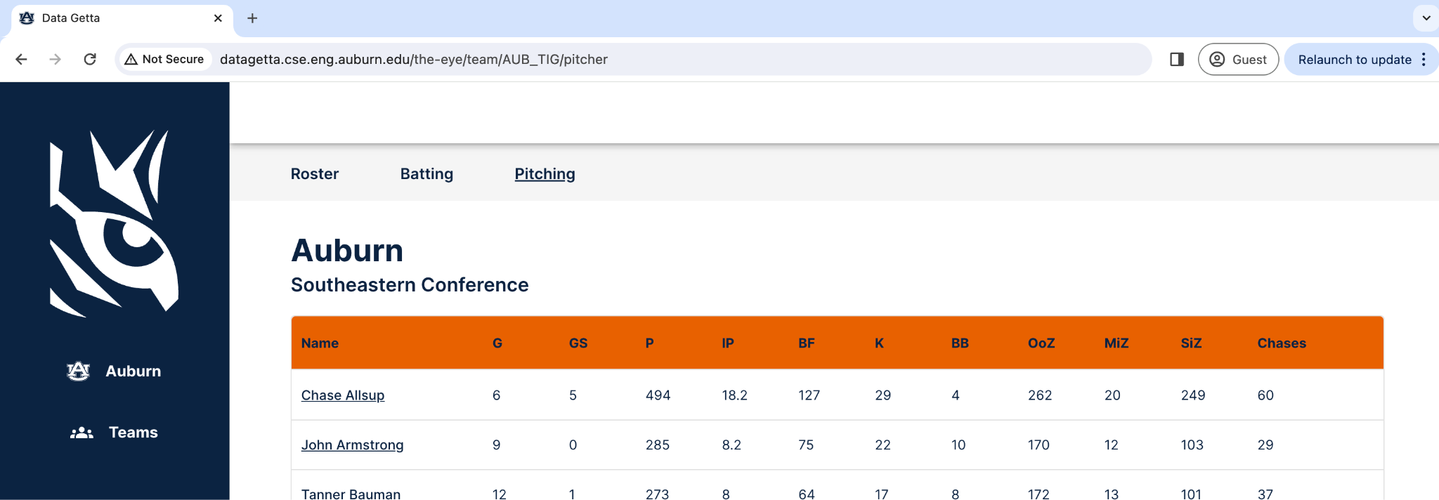

Once you click a player’s name their “Stats” page will appear

#### 

#### **View a Pitcher’s Statistics**

By clicking a player’s name, you are automatically taken to the “Stats” page. From there, you can view their specific stats and pitch counts.

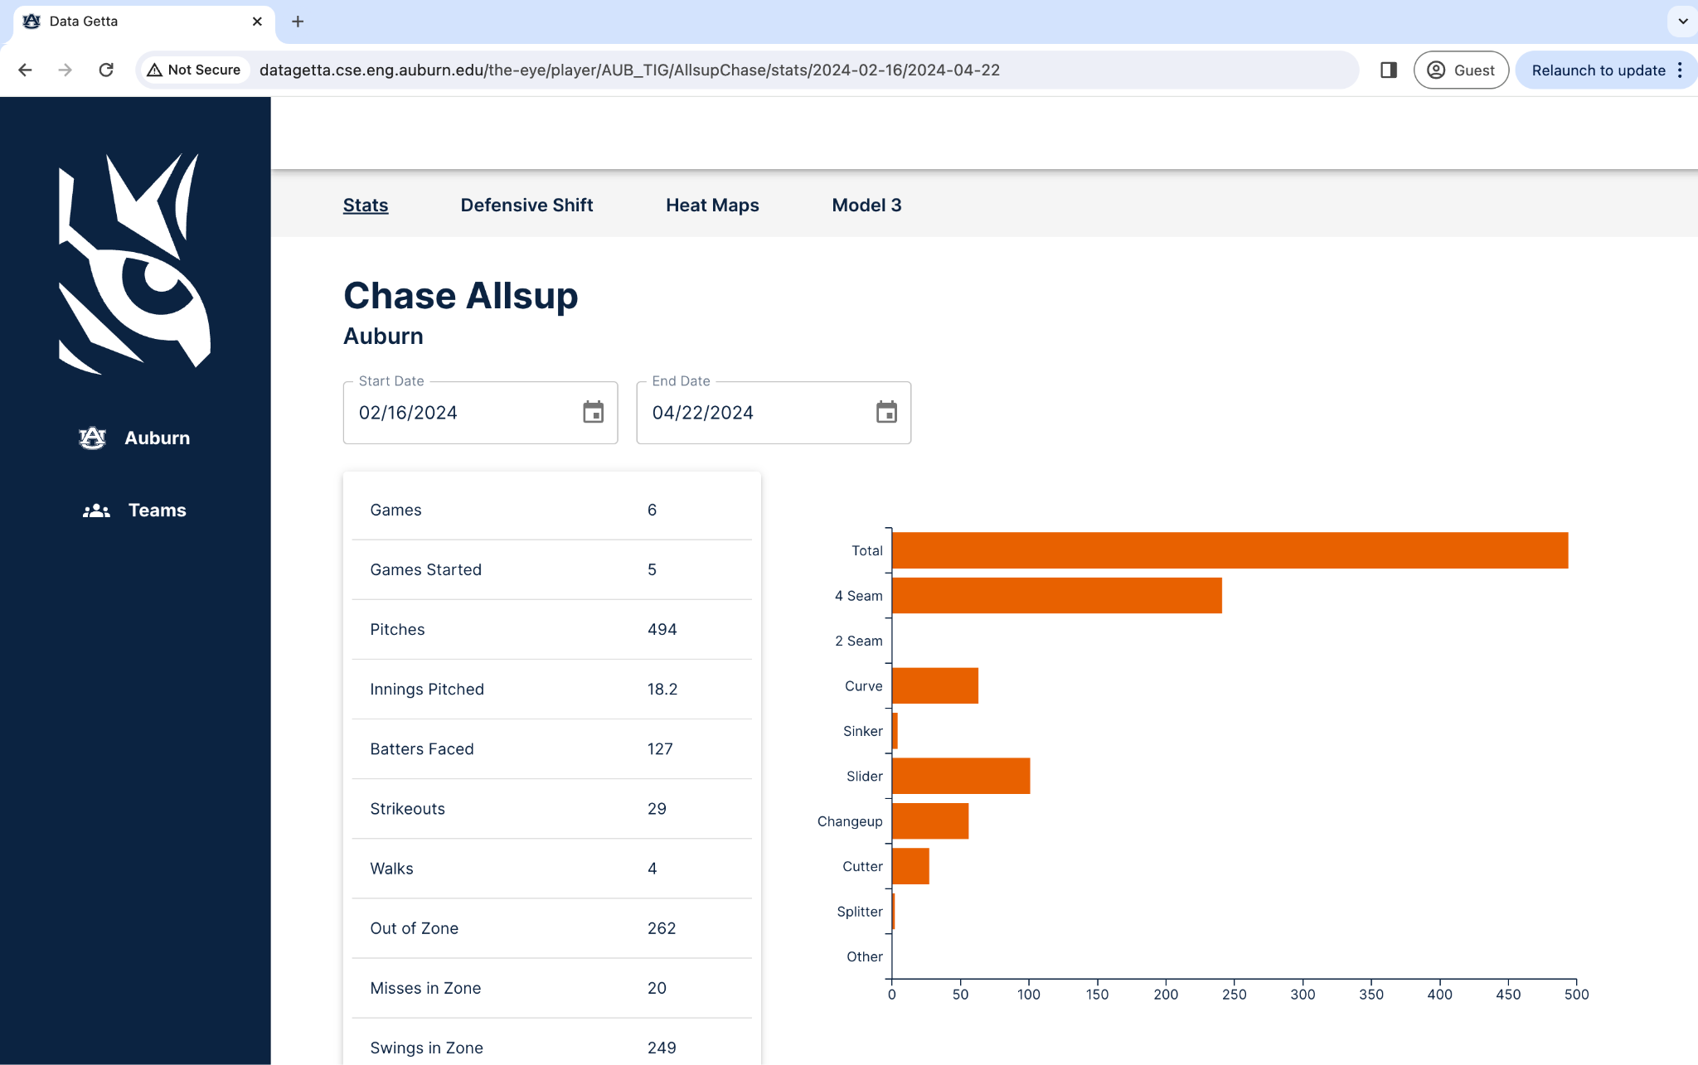

You also have the ability to filter the time frame of data selected. To do this, you can either click on the start or end date and manually type in a date, or click the calendar icon and select a date.

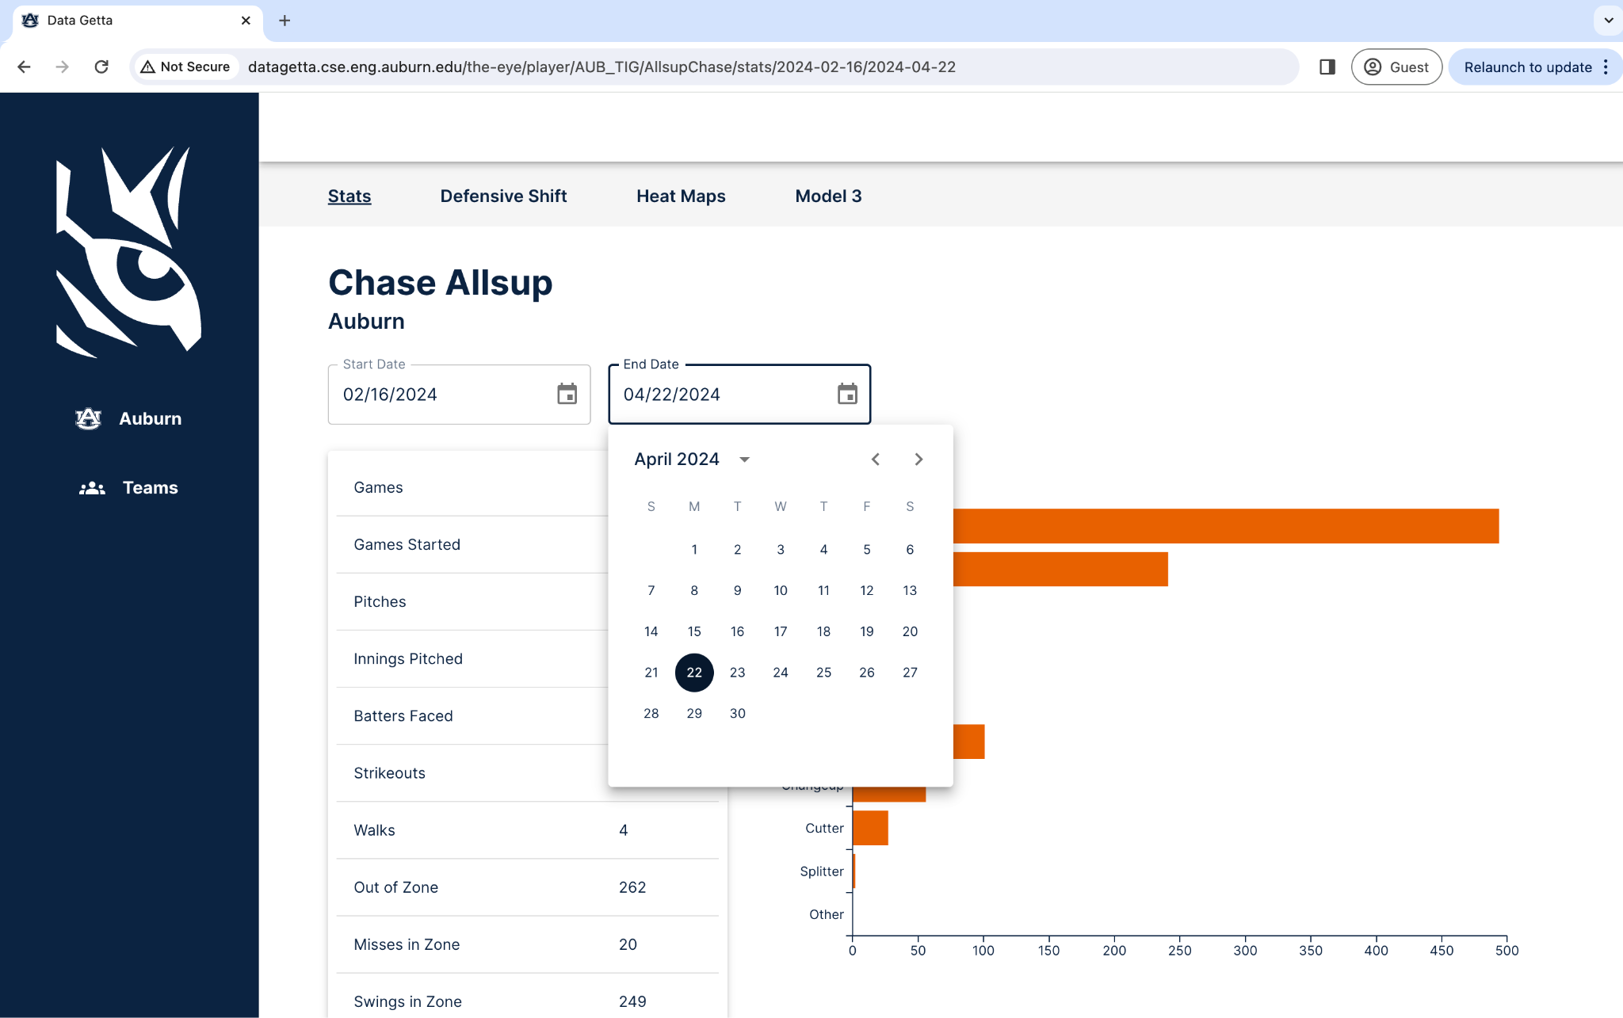

To navigate back to the “Stats” Page from another page within a player, click on “Stats” at the top bar.

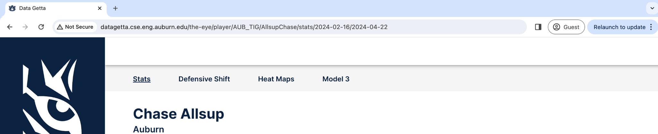

#### **View a Pitcher’s AI Models**

As of 4/26/24, for Version 1.0 of Data Getta, we have 3 models available to view: Defensive Shift, Heat Maps, and Run Values.

To Navigate to each model, click the specific model you want to view from the top bar



### 

### **View a Batter’s Page**

First, navigate to the Batting Page for the team you want to view

From there, click on the specific player you want to view



Once you click a player’s name their “Stats” page will appear

#### 

\***Note**: While on a batter’s page, you will notice you have the option to view 3 player models in addition to the statistics available. These models are intended for pitchers, and therefore will appear to be blank for batters. This is not an error with the system.

#### **View a Batter’s Statistics**

By clicking a player’s name, you are automatically taken to the “Stats” page. From there, you can view their specific stats.

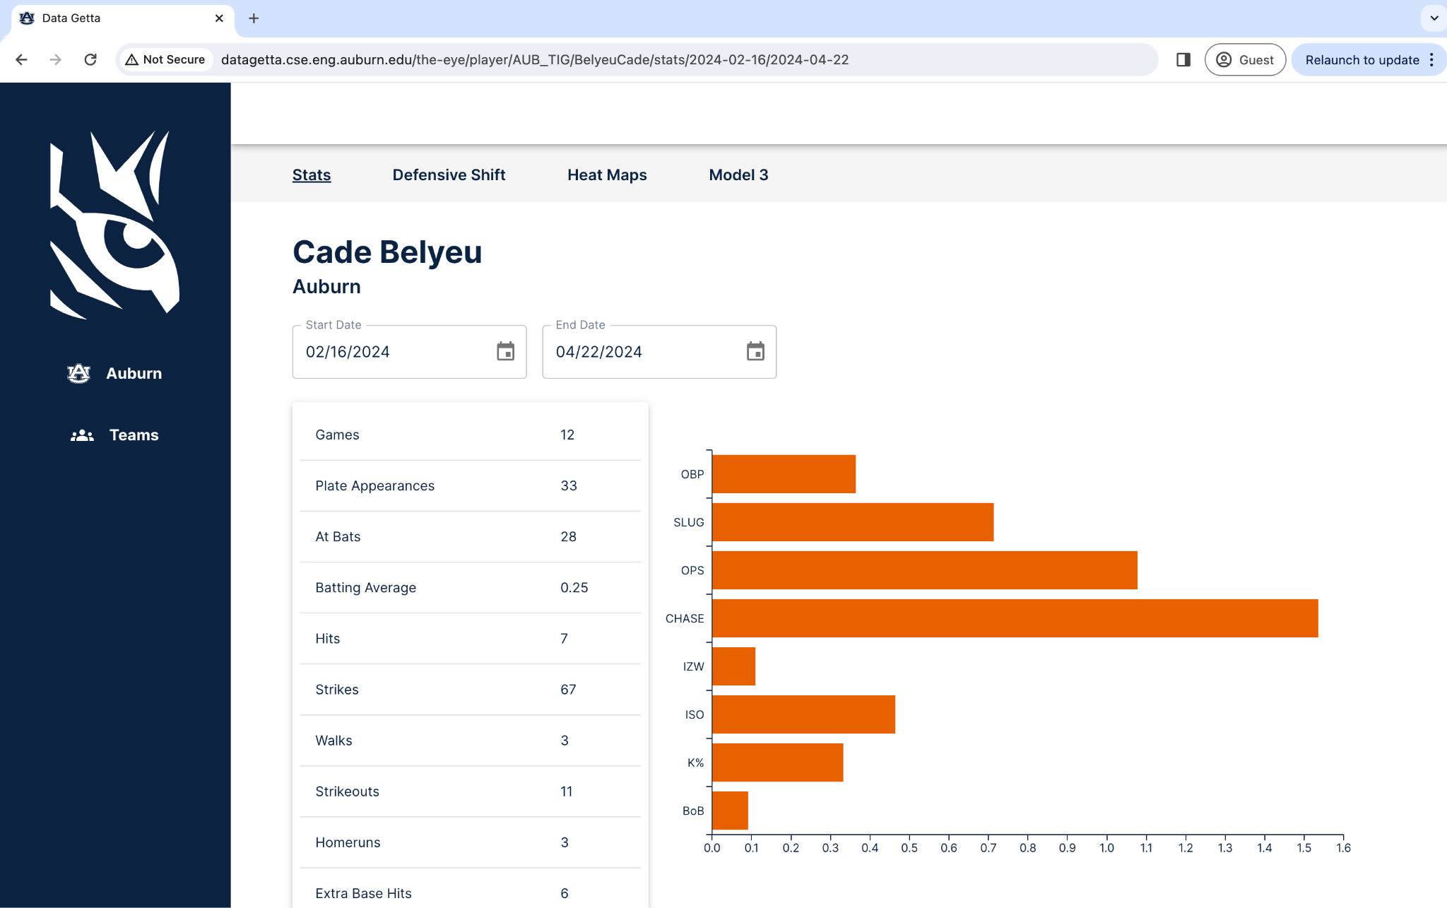

You also have the ability to filter the time frame of data selected. To do this, you can either click on the start or end date and manually type in a date, or click the calendar icon and select a date.

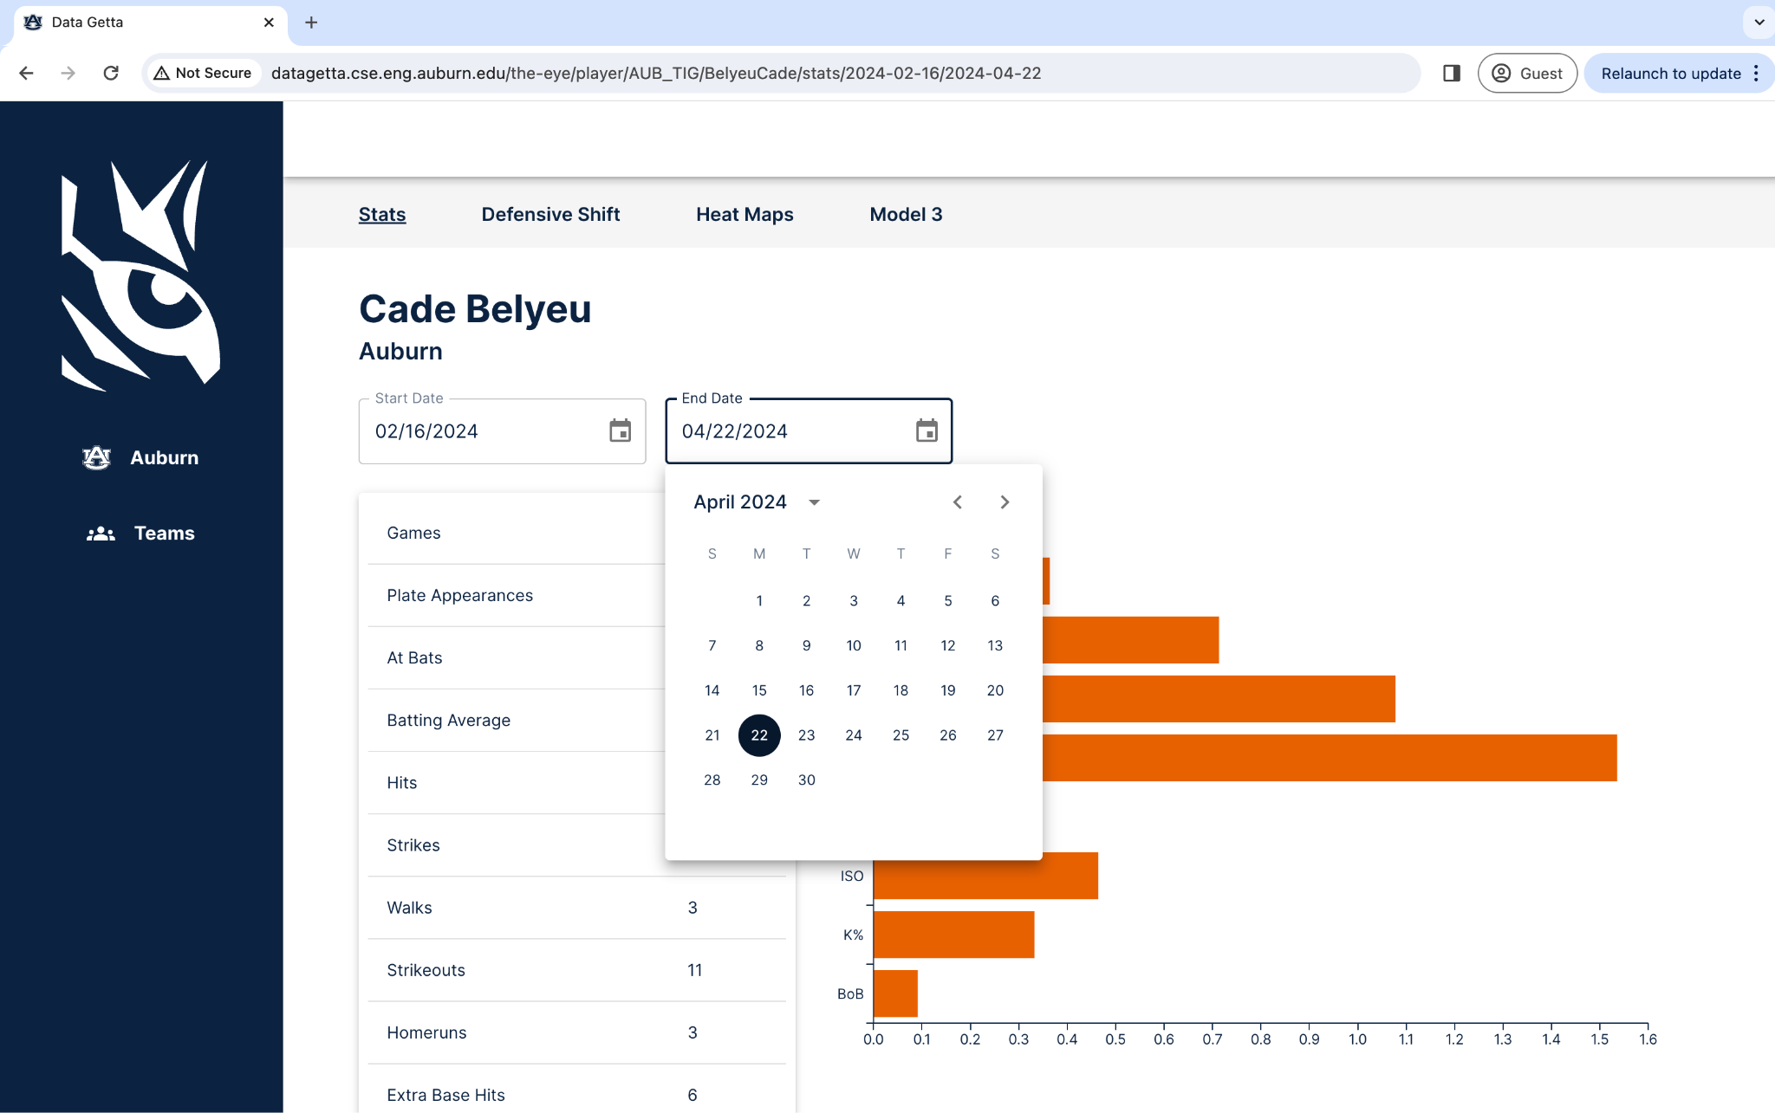

To navigate back to the “Stats” Page from another page within a player, click on “Stats” at the top bar.

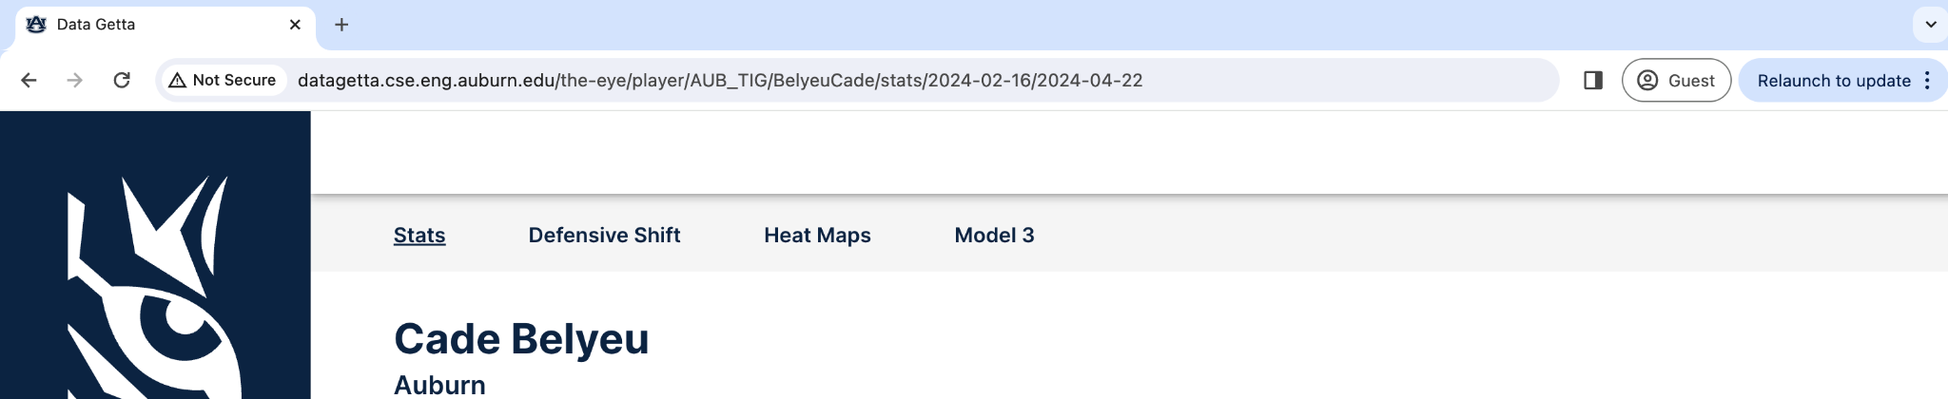

## **Connect to Auburn’s VPN**

**To download VPN**

1. Log in to AU Access
2. Go to My Campus Tab > Information Technology > click on AU Install
3. Scroll down until you see Palo Alto GlobalProtect (VPN Client)
   1. Click on it to see the download options
4. If you have a macbook, click the download link for mac. If you have a pc/windows computer, click the Windows 64-bit
5. Navigate to your downloads, and double click the installer. It should be a file named GlobalProtect
6. Follow the installer instructions

**To use VPN on a mac:**

1. Do one of the following:
   1. Launchpad -> find the globe with GlobalProtect
      1. 
   2. Navigate to your top bar (top right corner) and click the globe
      1. 
2. Log in using your AU Access credentials
3. Approve the DUO factor authentication
4. You should be connected

**To use VPN on a windows:**

1. Do one of the following:
   1. Windows start -> search GlobalProtect -> open it
   2. Navigate to the lower toolbar (right bottom corner) -> click the up arrow -> click the globe icon
      1. 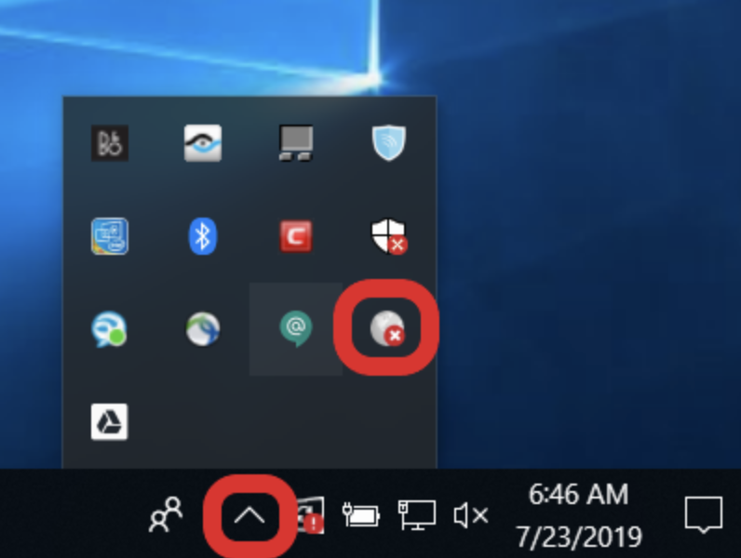
2. Log in using your AU Access credentials
3. Approve the DUO factor authentication
4. You should be connected